“Enhancement of Spectrum Efficiency in Satellite Communication Applying Prediction Model of Machine Learning Technique”

# A

**MINOR PROJECT REPORT**

***Submitted to***

***partial fulfillment of the requirement for the award of the degree of***

**BACHELOR OF TECHNOLOGY IN**

**ELECTRONICS & TELECOMMUNICATION ENGINEERING**

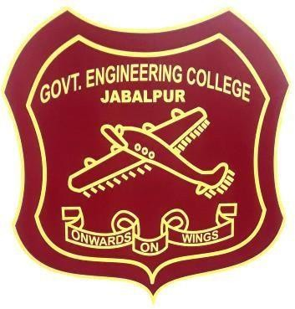

|  |  |  |
| --- | --- | --- |
|  | **Submitted By** |  |
| **Sakshi Sirohiya** |  | **(0201EC18ME13)** |
| **Sakshi Sirohiya** |  | **(0201EC18ME13)** |
| **Sakshi Sirohiya** |  | **(0201EC18ME13)** |
| **Sakshi Sirohiya** |  | **(0201EC18ME13)** |
| **Sakshi Sirohiya** |  | **(0201EC18ME13)** |

**Under the Guidance of Prof. Amit Baghel (Asst. Professor)**

**DEPARTMENT OF ELECTRONICS & TELECOMMUNICATION ENGINEERING**

**JABALPUR ENGINEERING COLLEGE, JABALPUR (M.P.)**

**(Established in 1947 as Government Engineering College, Jabalpur)**

**(Declared Autonomous by Government of Madhya Pradesh and RGPV, Bhopal)**

**SESSION: 2018-2020**

# DEPARTMENT OF ELECTRONICS AND TELECOMMUNICATION ENGINEERING

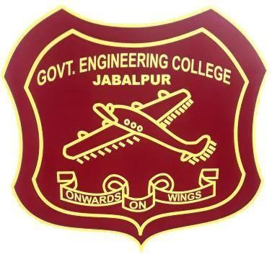

**CANDIDATE’S DECLARATION**

We hereby declare that the work, which is being presented in this Minor Project Report, entitled “Enhancement of Spectrum Efficiency in Satellite Communication Applying Prediction Model of Machine Learning Technique” in partial fulfillment for the award of Bachelor of Technology degree in Electronics and Telecommunication Engineering, submitted in the Department of Electronics and Telecommunication Engineering, Jabalpur Engineering College, Jabalpur, is an authentic record of our own work carried out under the guidance of Prof. Amit Baghel, Asst. Professor, Electronics and Telecommunication Engineering, Jabalpur Engineering College, Jabalpur.

We havenot submitted the matter embodied in this report for award of any other degree or diploma.

Sakshi Sirohiya (0201EC18ME13)

Sakshi Sirohiya (0201EC18ME13)

Sakshi Sirohiya (0201EC18ME13)

Sakshi Sirohiya (0201EC18ME13)

Sakshi Sirohiya (0201EC18ME13)

**Date:**

**Place:**

**DEPARTMENT OF ELECTRONICS AND TELECOMMUNICATION ENGINEERING**



**CERTIFICATE**

This is to certify that Minor Project Report entitled **“**Enhancement of Spectrum Efficiency in Satellite Communication Applying Prediction Model of Machine Learning Technique**”** submitted by **Sakshi Sirohiya (0201EC18ME13), Sakshi Sirohiya (0201EC18ME13), Sakshi Sirohiya (0201EC18ME13), Sakshi Sirohiya (0201EC18ME13),** have been carried out under my guidance and supervision. This report is forwarded for submission towards the partial fulfillment for the award of **Bachelor of Technology** degree in **Electronics and Telecommunication Engineering.**

Supervisor:

Forwarded to:

**Dr. Bhavana Jharia**

(Professor & HOD)

**Prof. Amit Baghel**

(Asst. Professor)

**DEPARTMENT OF ELECTRONICS AND TELECOMMUNICATION ENGINEERING**



**CERTIFICATE OF APPROVAL**

This is to certify that Minor Project Report entitled **“**Enhancement of Spectrum Efficiency in Satellite Communication Applying Prediction Model of Machine Learning Technique**”** submitted by **Sakshi Sirohiya** (**0201EC18ME13**), **SakshiSirohiya** (**0201EC18ME13**), **SakshiSirohiya** (**0201EC18ME13**) , **SakshiSirohiya** (**0201EC18ME13**) is accepted towards partial fulfillment for the award of **Bachelor of Technology** degree in **Electronics and Telecommunication Engineering.**

**INTERNAL EXAMINER EXTERNAL EXAMINER**

**DATE: DATE:**

# ACKNOWLEDGEMENT

It is a matter of extreme honor and privilege for us to offer our grateful acknowledgement to our respected guide **Prof. Amit Baghel**, **Asst. Professor, Electronics and Telecommunication Engineering, Jabalpur Engineering College, Jabalpur** to give us a chance to work under his guidance and supervision. We also grateful for all kinds of support and inspiration, constant encouragement, sincere criticism and valuable guidance which were given by him throughout the investigation and preparation of this thesis.

We would also like to take this opportunity to present my sincere regards to **Prof. Mahesh Prasad Parsai, Dr. Bhavana Jharia(HOD)**, **Dr. Agya Mishra, Dr. Kanchan Cecil, Prof. Sunil Kumar Singh, Prof. Namrata Sahyam, Prof. Garima Tiwari, Prof. Devendra Kumar Meda, and all faculty members of the Department of Electronics and Telecommunication Engineering,** for their valuable advice and assistance during our studies at Jabalpur Engineering College Jabalpur, and their support.

We want to express our sincere gratitude to **Dr. A. K. Sharma**, **Principal, Jabalpur Engineering College, Jabalpur**, for his valuable support and facilities provided to us to carry out this work at Jabalpur Engineering College, Jabalpur (M.P.).

We have a great pleasure in expressing our deep sense of gratitude to all the respected faculty members of Electronics and Telecommunication department.

Above all my deepest love and gratitude is devoted to my parents. They are always a source of love, support and encouragement.

Last but not least, we also thankful to Almighty God for giving us the patience and the strength for guiding us make choices in life and helping us in such mysterious way that is impossible for us to explain.

**Sakshi Sirohiya**